**OXFORD COLLEGE OF ENGINEERING AND MANAGEMENT**

 (Afilliated to PU)

**Gaindakot-2, Nawalpur**

**Lab Report**

**Database Management System**

Course Code: CMP 226

BCA Second Year, Fourth Semester

**Submitted To:**

**Asst. Professor Sunil Kumar**

**Department Of BCA**

**Submitted By:**

**Debid Rana Magar**

**Section: A**

**Roll No: 24**

# Lab 1

## 1. Sql Query to Create Database

create database david

## 2. Sql Query to Create Table

create table employee

(

empid int primary key,

empname varchar(50),

empcity varchar(20),

empmob varchar(10),

empsalary decimal(10,2)

)

## 3. Sql Query to Insert Records

insert into employee values ('1','Ram','Gaidakot','9848938487','40000')

insert into employee values ('2','Sita','Bharatpur','9844397487','25000')

insert into employee values ('3','Hari','Bharatpur','984974872','35000')

insert into employee values ('4','Som','Gaindakot','984246332','20000')

## 4. Sql Query to View Records

select * from employee

## Result:

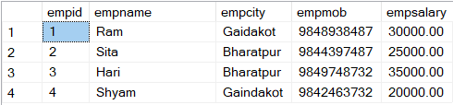

# Lab 2

## 1. Sql Query to Update Table

update employee set empsalary= '30000' where empid='1'

## 2. Sql Query to Delete Records

delete from employee where empid='3'

## Result:

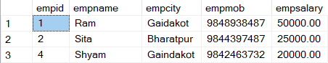

## 3. Sql Query to Drop Table

drop table employee

## 4. Sql Query to Drop Database

drop database david